Project 1: Use of LED Lights

The project of the creation of a set of Racing Lights that are used when beginning a race.

The Code in Arduino IDE:
int ledR1 = 10;
int ledR2 = 9;
int ledB = 6;
int ledG = 5;

void setup() {
// put your setup code here, to run once:
pinMode(ledR1, OUTPUT);
pinMode(ledR2, OUTPUT);
pinMode(ledB, OUTPUT);
pinMode(ledG, OUTPUT);
}

void loop() {
// put your main code here, to run repeatedly:
digitalWrite(ledR1, HIGH);
delay(1000);
digitalWrite(ledR2, HIGH);
delay(1000);
digitalWrite(ledB, HIGH);
delay(1000);
digitalWrite(ledR1, LOW);
digitalWrite(ledR2, LOW);
digitalWrite(ledB, LOW);
digitalWrite(ledG, HIGH);
delay(2000);
digitalWrite(ledG, LOW);
delay(5000);
}

The connection setup:
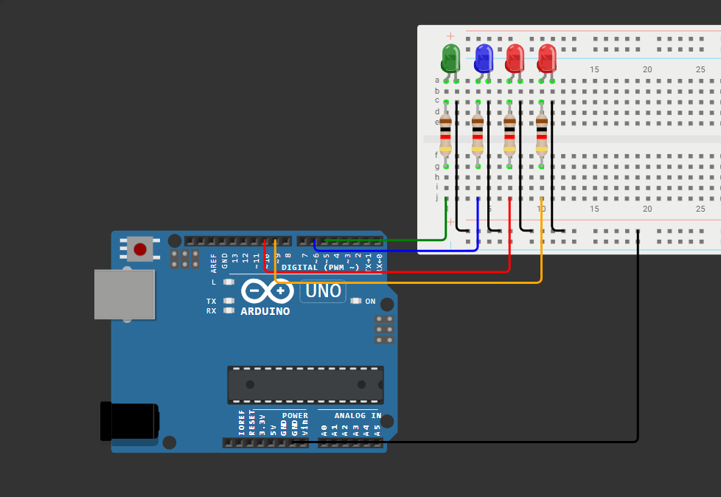

Process:
Once uploaded:
- the first red LED will turn on
- wait 1 second
- 2nd Red will turn on
- wait 1 second
- Blue LED will turn on
- Wait 1 second
- Red 1, Red 2 and Blue LEDs will turn off and the Green LED will turn on
- Wait 2 seconds
- Green LED will turn off and will wait for 5 seconds for the loop to begin again

